

**Q2. Create a EC2 AWS instance and lunch it and share the details in a pdf file which should contain the details of your orgs.**

**Create a EC2 AWS instance and lunch it and share the details in a pdf file which should contain the details of your orgs.**

**Answer:**

Creating an AWS EC2 instance using the AWS Management Console or AWS CLI.

Here's a general step to creating an EC2 instance:

**Steps to Create an EC2 Instance in AWS:**

## Create Free Tier products with a new AWS account.

**AWS link open account:** [**https://portal.aws.amazon.com/billing/signup#/start/email**](https://portal.aws.amazon.com/billing/signup#/start/email)

* Sign up for a Free **AWS account**. **Creating** an **AWS account** is free and gives me immediate **access** to the **AWS Free Tier**
* Gain free, hands-on experience with the AWS platform, products, and services

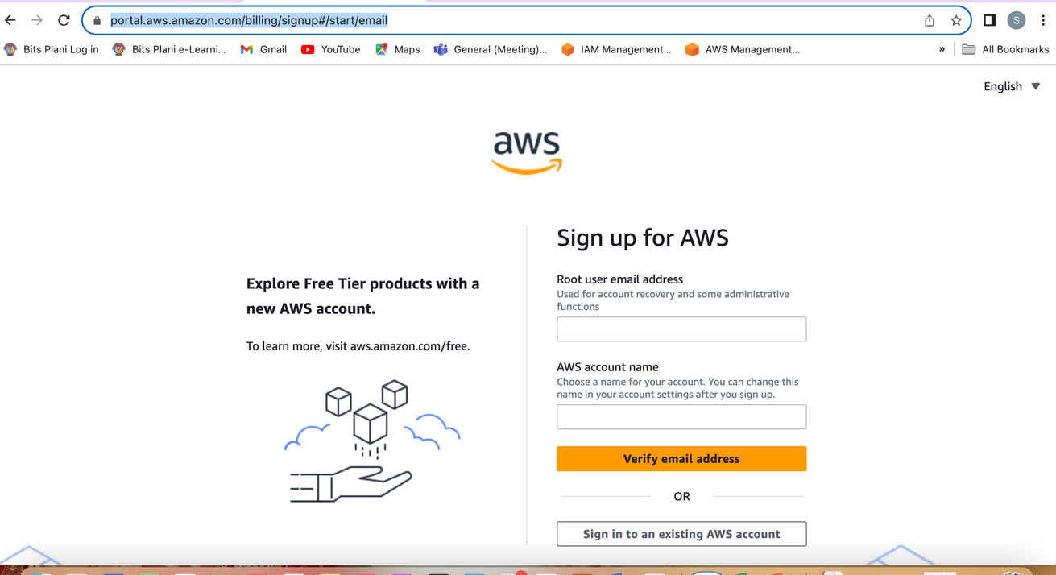

* 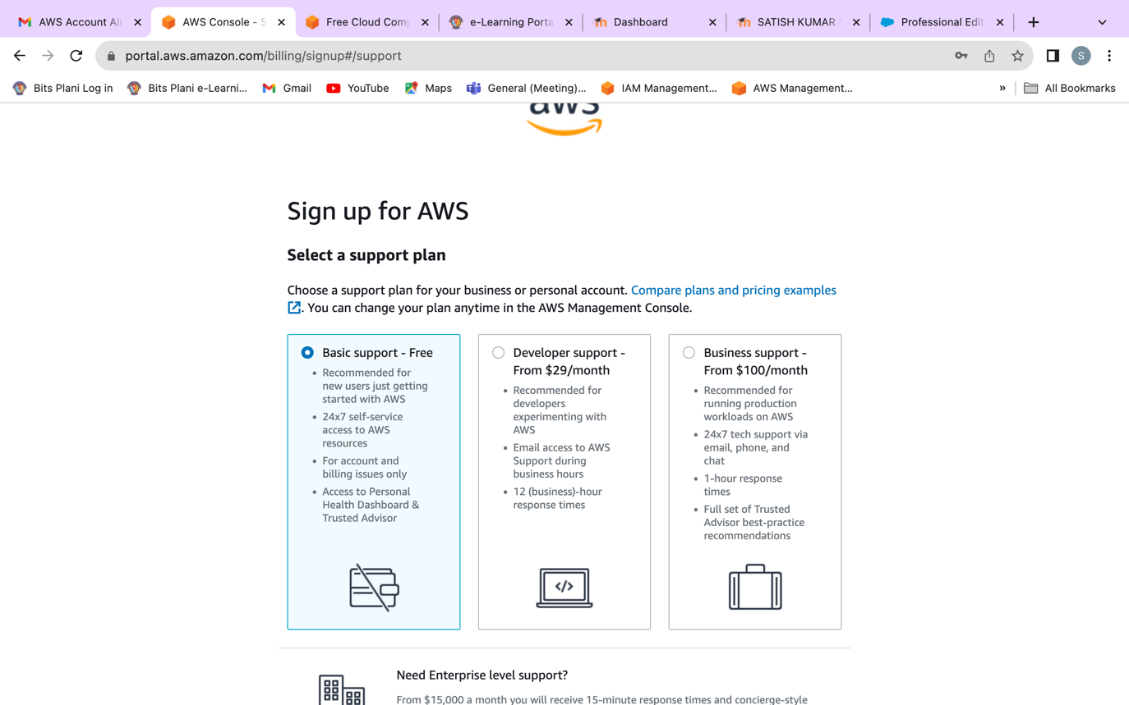**Select Basic support Free tier account.**

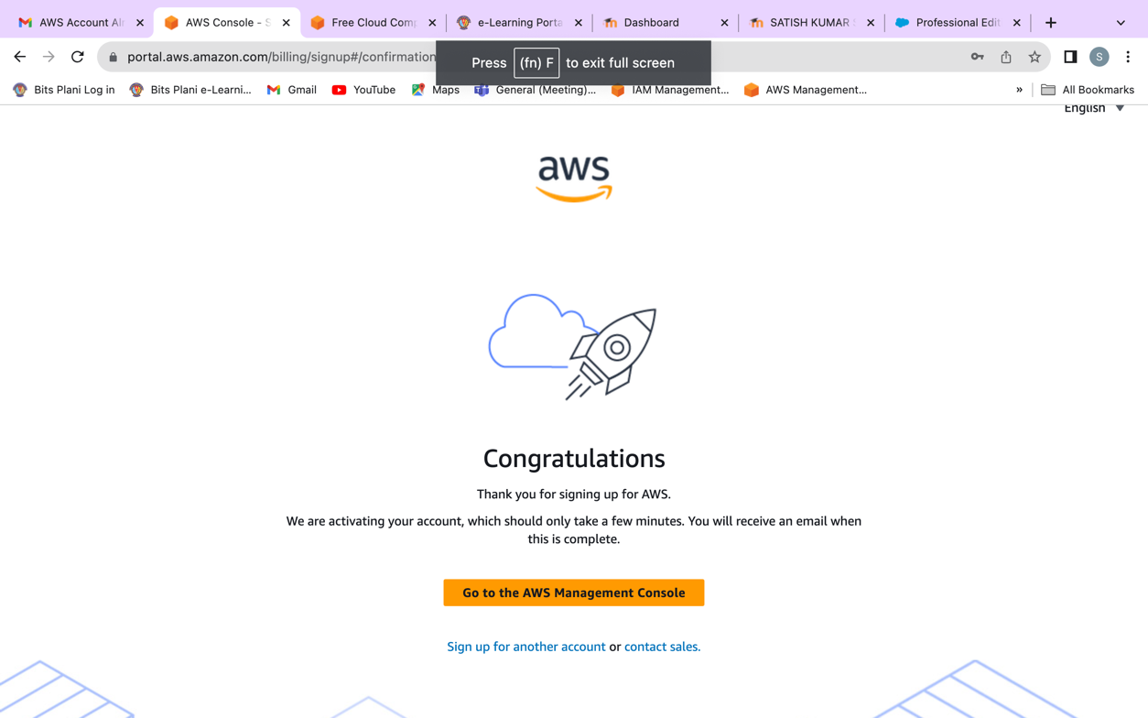

1. **Sign in to the AWS Management Console:**

* Navigate to the AWS Management Console.
* Sign in with AWS account credentials.

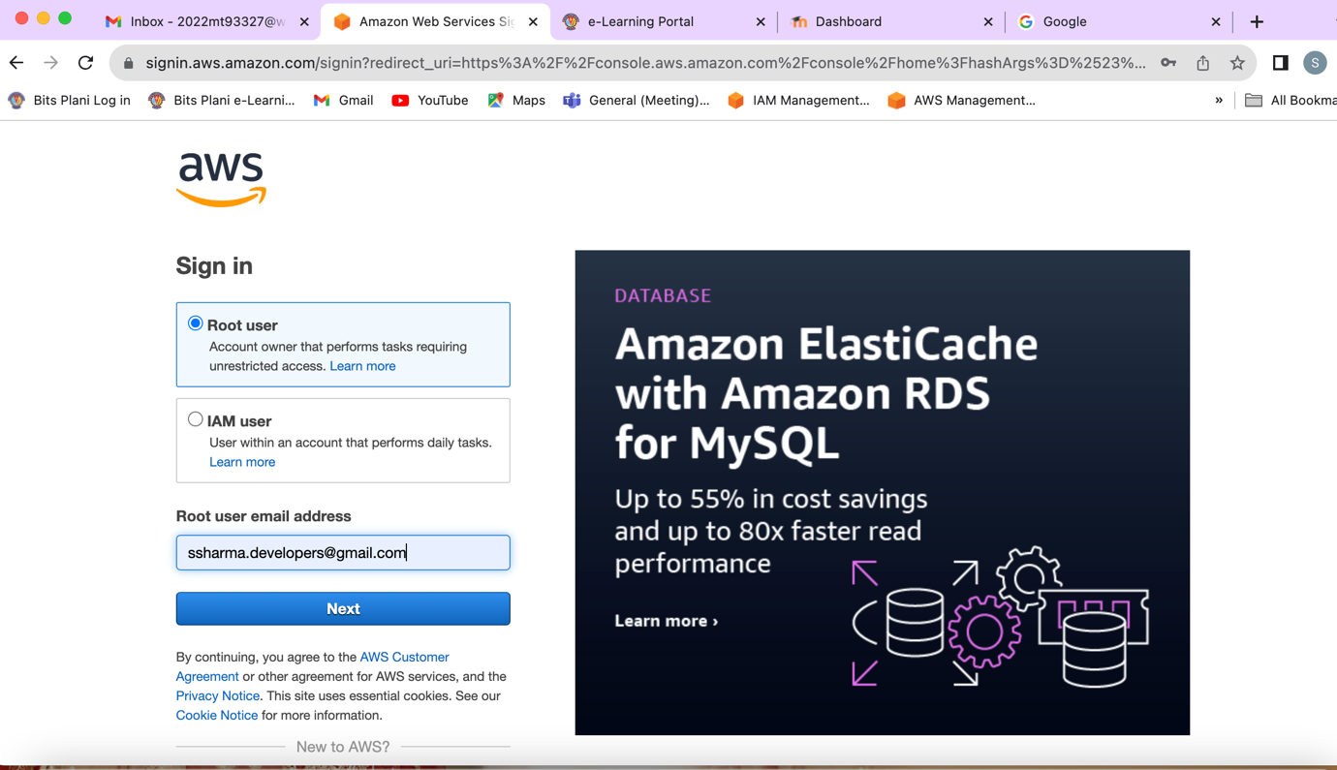

1. **Navigate to EC2:**

* In the AWS Management Console, search for and select "EC2" under the "Find Services" search bar or find it under the "Compute" section.

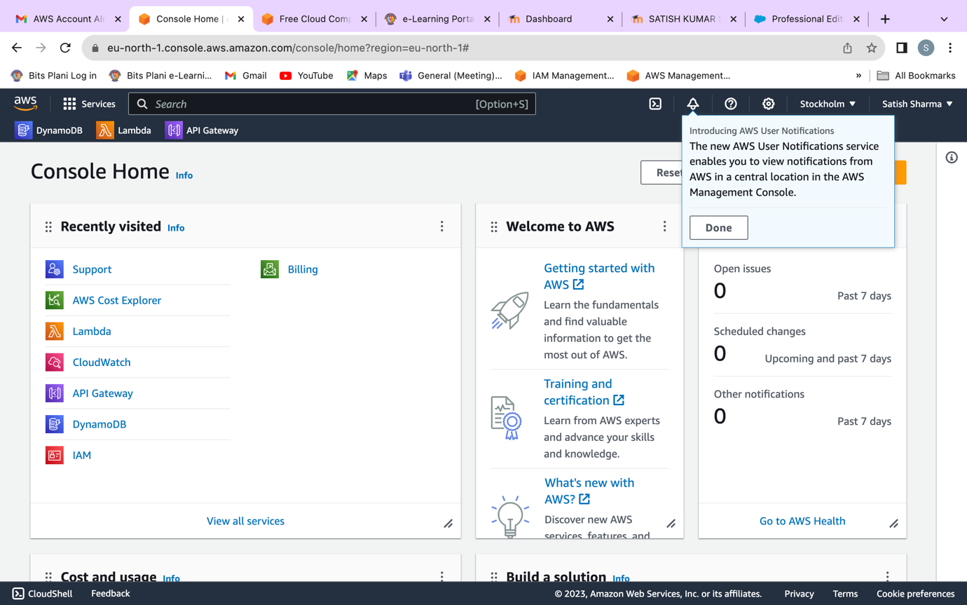

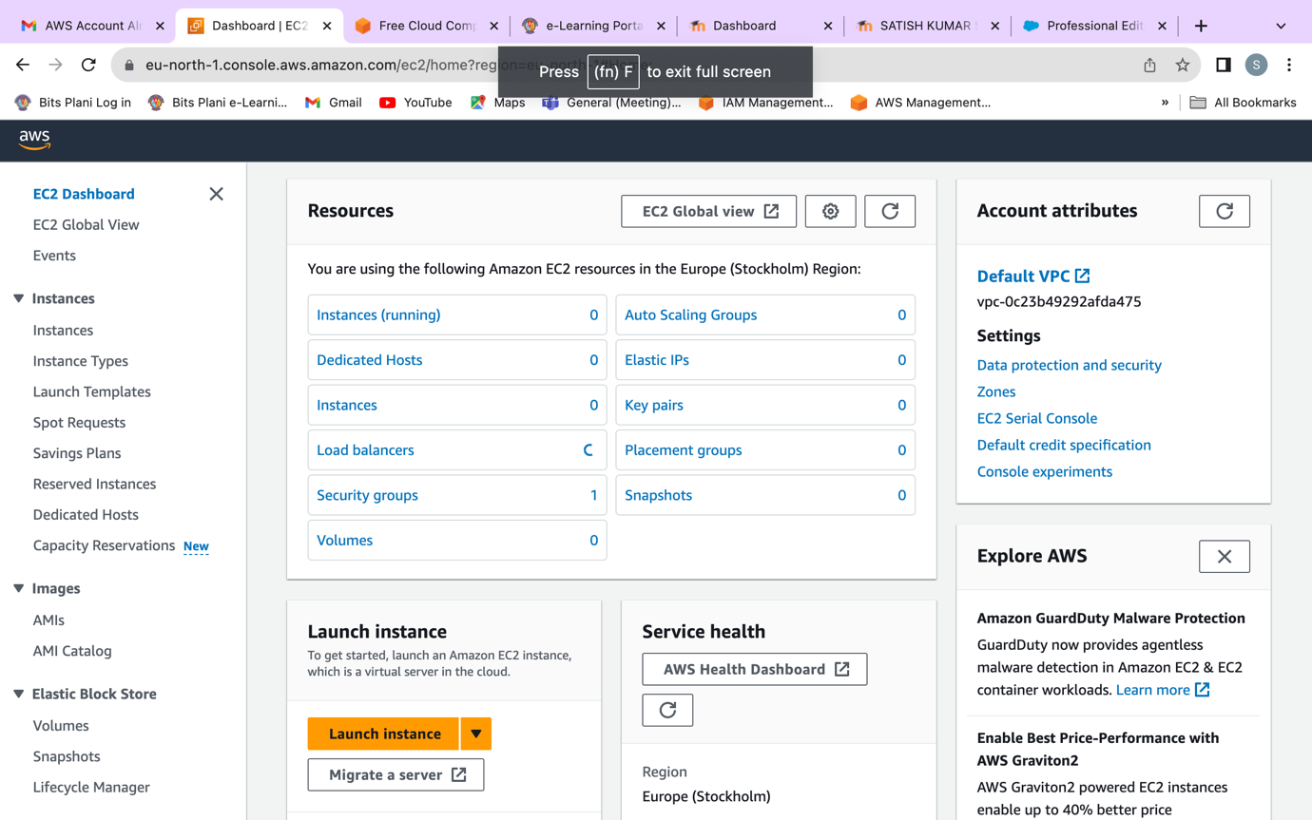

1. **Launch an Instance:**

* Click on the "Instances" in the left-hand navigation pane.
* Click the "Launch Instance" button.

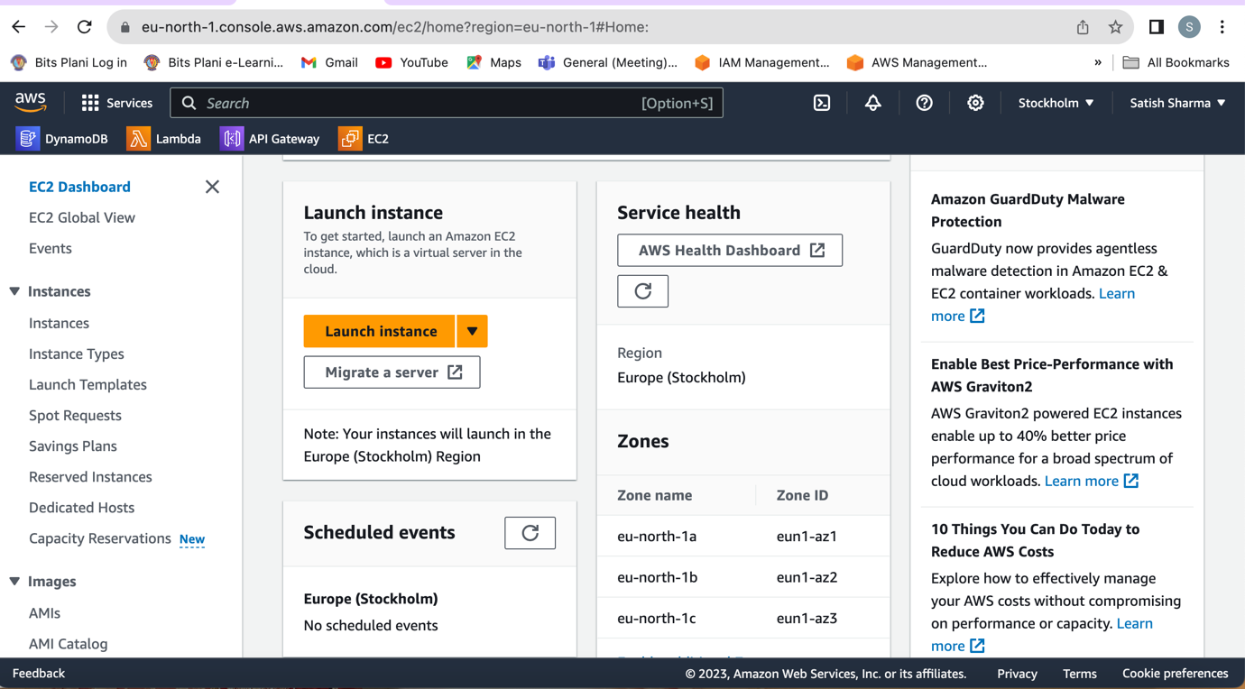

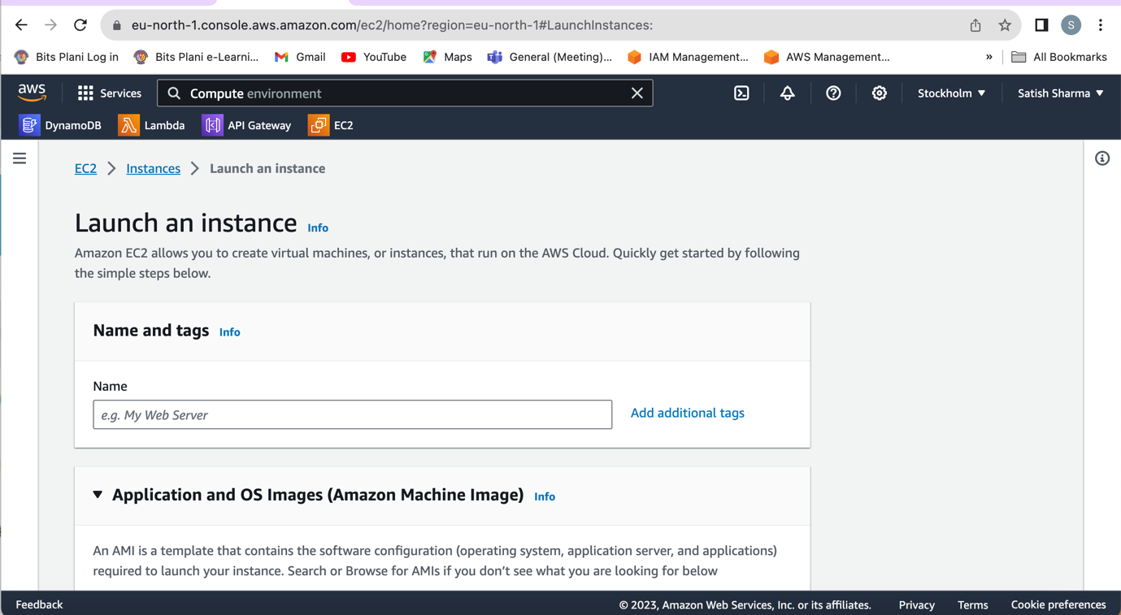

1. **Choose an Amazon Machine Image (AMI):**

* Select an AMI based on requirements. This is the operating system for your instance.

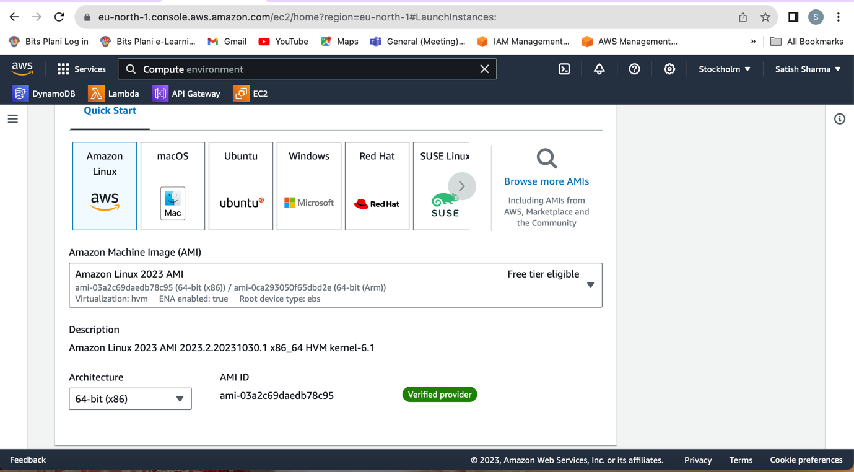

1. **Choose an Instance Type:**

* Select the instance type based on your workload needs (e.g., t2.micro, t3.medium).

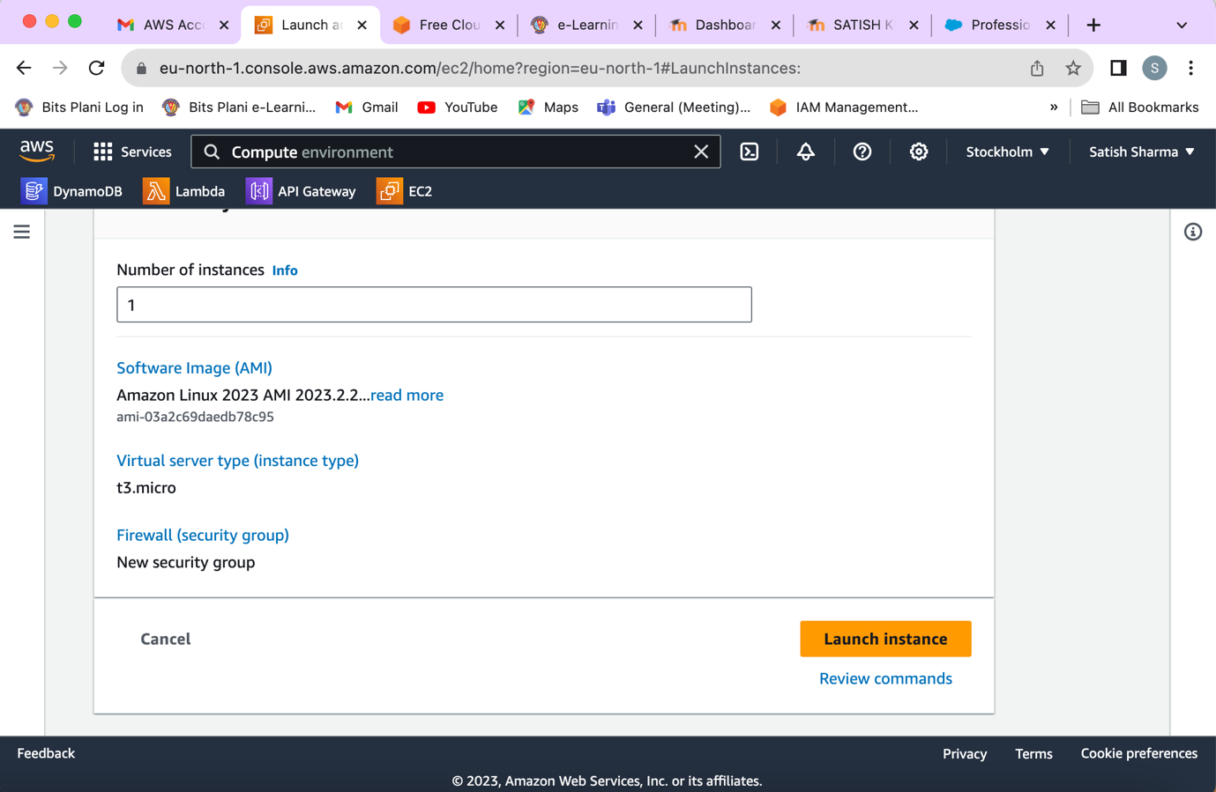

1. **Configure Instance:**

* Configure instance details, including the number of instances, network settings, and IAM role.



1. **Add Storage:**

* Specify the storage settings for your instance.

1. **Add Tags (Optional):**

* Add tags to your instance for easier identification.

1. **Configure Security Group:**

* Configure security groups to control inbound and outbound traffic to your instance.

1. **Review and Launch:**

* Review your configurations and click "Launch."

1. **Create a Key Pair:**

* Choose an existing key pair or create a new one. This is essential for securely connecting to your instance.

1. **Launch Instances:**

* Click "Launch Instances."

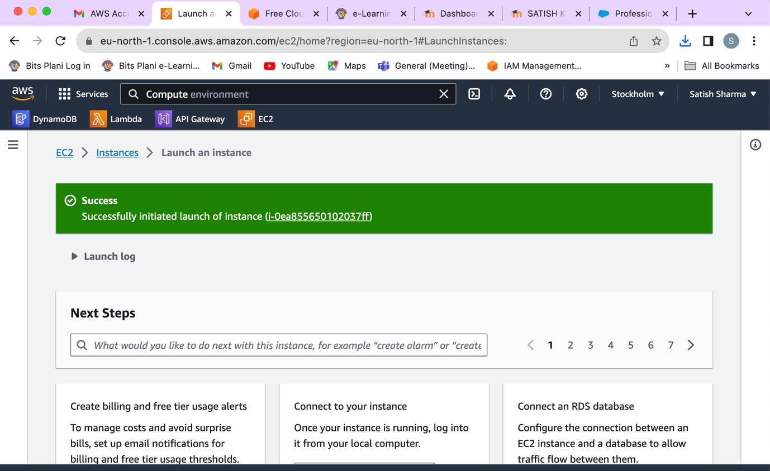

* Instances created successful and launched successfully.
* Ensuring to follow AWS best practices for security, such as using secure key pairs and configuring security groups appropriately.
* Never share sensitive information publicly, including your AWS access credentials, key pairs, or organizational details.
* If you need specific information about your organization's AWS account, it
* After launching the instance, we can view the details such as the instance ID, public IP address, and other relevant information in the AWS Management Console.
* Always follow AWS security best practices, and avoid sharing sensitive information publicly. If you need to share details, consider redacting or excluding sensitive information and share only the necessary details for the intended purpose.
* AWS CLI & AWS SDKs To view the details for your organization You can use one of the following commands to view details of an organization:
  + AWS CLI: describe-organization the following example shows the information included in the output of this command. $ aws organizations describe-organization

**Next: I am going to disable and remove all the resources.**

1. **Remove all the resources and terminating the instances to avoid billing:**

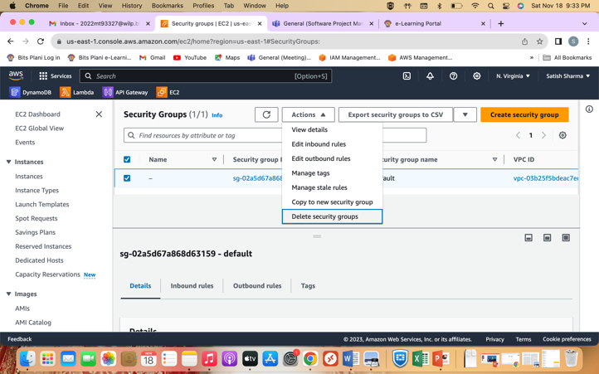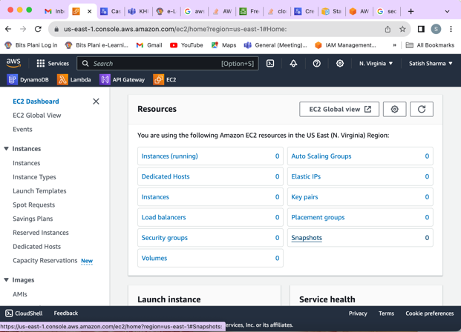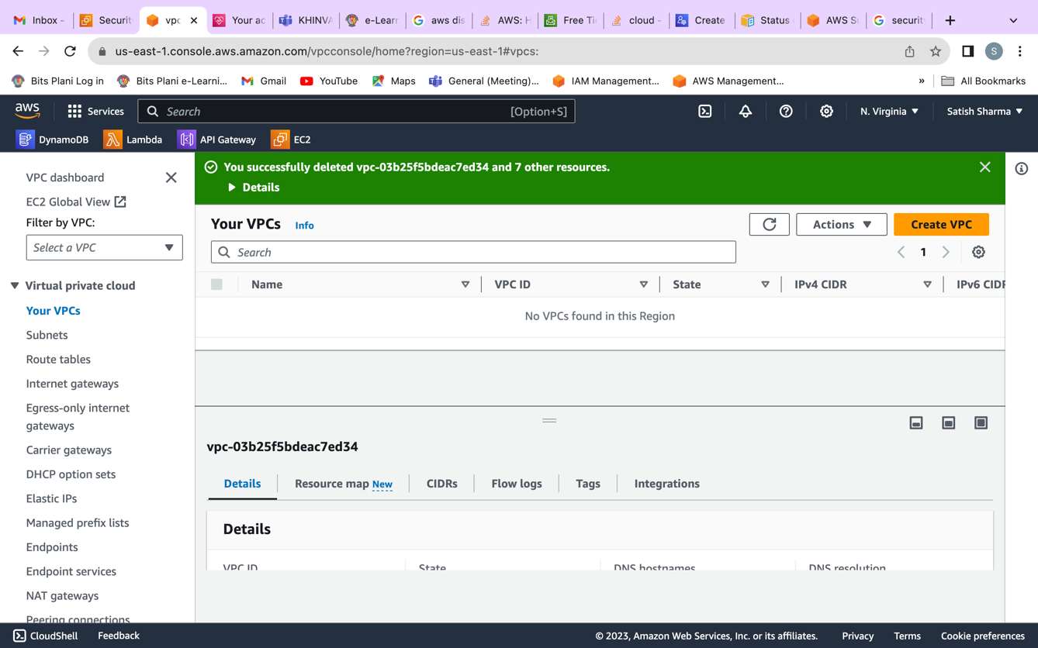

**Conclusions**

Created an AWS EC2 instance using the AWS Management Console and launch the instances, allocate the required resources, assign them key, and finally terminated after the testing.

Thank You.